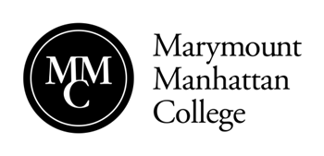
New York City Seminar Funding Request and Reimbursement Guidelines

Faculty interested in requesting funds to sponsor an event associated with their New York City Seminar must follow the procedures outlined below. Please note that requests should be submitted at least 10 business days in advance of the date of the activity/event.

Funding Limits
Each NYC Seminar will be allocated $500 in funding for the Fall 2018 semester for the faculty member to use in sponsoring specific field trips and group events that enhance student learning.

Submitting Your Request

- Requests for funding must be made at least 10 days prior to the scheduled date of the event or activity.
- The following must be submitted:
- A completed a New York City Funding Request Form
- An attached narrative and/or other documentation that describes the activity or event
- A proposed budget (outlined on request form)
- Indication of how the faculty member is planning to cover the costs associated with the activity:
  - Expense Report: The faculty requests reimbursement for expenses incurred by them for the event/activity.
  - Check Request: A check is prepared for the vendor in advance of the event. The documentation should specify the amount of the check being requested and if the check should be mailed to the vendor, or if the faculty member will pick it up from MMC. Address and contact information should be provided in the supporting documentation. Requests for checks must be made at least 10 business days before the check is needed. Requests submitted less than 10 days in advance will not be ready in time for the event.
- Requests require a review by the New York City Seminar Coordinator and the Assistant Dean of Academic Administration.
- You will be notified of the approval or denial of the application via email. A copy of your Request Form, indicating the award amount (if approved) will be forwarded to you as well.

Submitting an Expense Report
In order to receive reimbursement for any expenses incurred personally by the faculty member, you must:

- Submit all original receipts using the Marymount Manhattan approved Expense Report Form. You can only be reimbursed for the actual receipts submitted.
- The Expense Report Form should be submitted to Academic Affairs within 5 business days after the event has ended.

