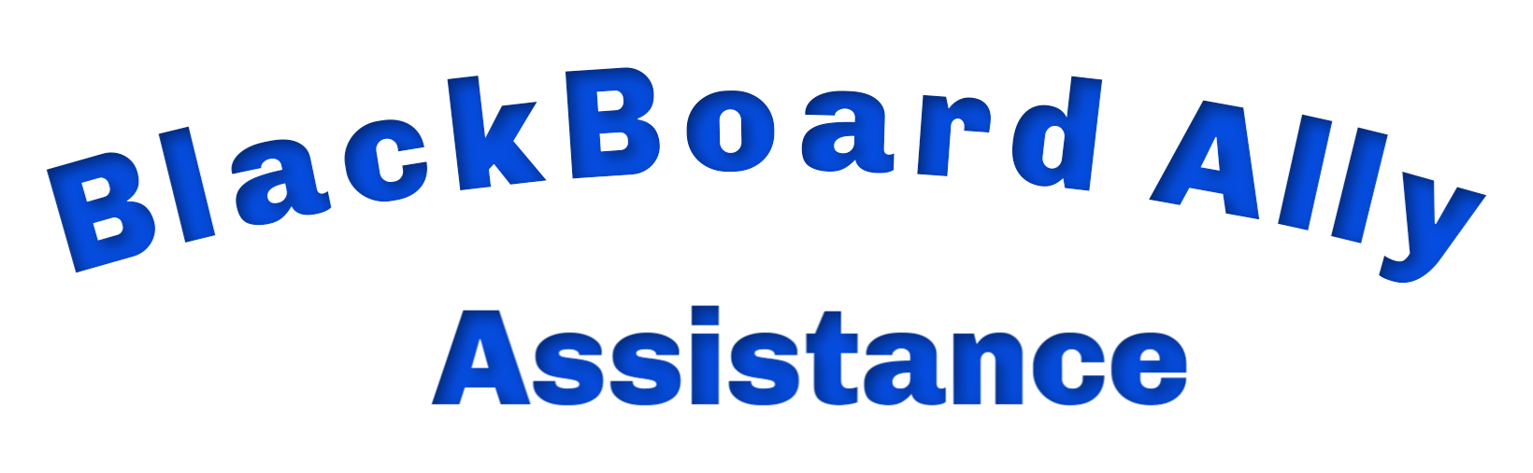

Uploading Content to Blackboard

Checking Blackboard Content Accessibility
(With Blackboard Ally Software)
  - Word Documents
  - Pdf Documents
  - Images
  - Videos

Note: Accessibility refers to making the content useable to all students including those with disabilities that are or will be taking a course.

Contact:
Michael S. Johnson
Assistive Technology Specialist
212-774-0782
mjohnson@mmm.edu
CH 412 Office 1 (Multi-Faith Center)


